 | Министерство науки и высшего образования Российской Федерации  Калужский филиал  федерального государственного бюджетного  образовательного учреждения высшего образования  «Московский государственный технический университет имени Н.Э. Баумана (национальный исследовательский университет)»  (КФ МГТУ им. Н.Э. Баумана)
ФАКУЛЬТЕТ _ИУК «Информатика и управление»______________
КАФЕДРА __ИУК4 «Программное обеспечение ЭВМ, информационные технологии»

ЛАБОРАТОРНАЯ РАБОТА №3

«Особенности среды Android Studio для разработки приложений Android. Простое Android приложение»

ДИСЦИПЛИНА: «Разработка мобильного ПО»

Выполнил: студент гр. ИУК4-52Б |  | _________________ (______Губин Е.В._____)  (Подпись) (Ф.И.О.)
Проверил: |  | _________________ (_____Прудяк П.Н._____)  (Подпись) (Ф.И.О.)
Дата сдачи (защиты):
Результаты сдачи (защиты):
- Балльная оценка:
- Оценка:
Калуга, 2024 г.

Цель: приобретение практических навыков разработки приложений с несколькими Activity и Intent-объектами.
Задачи:
1. Изучить механизм создания многоэкранных приложений на платформе Android
2. Научиться разрабатывать приложения с использованием явного и неявного вызова классов
3. Понять особенности реализации Android-приложений с использованием Intent-объектов

Формулировка задания:

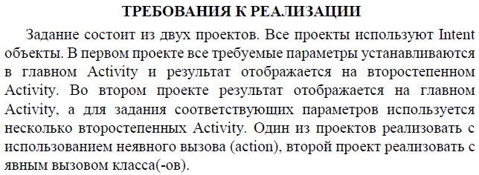
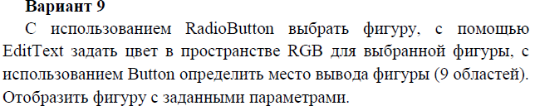

Проект 1

Листинг программы:

СircleView.kt (рисует круг с использованием холста canvas):

package com.example.lw_3_1

import android.content.Context
import android.graphics.Canvas
import android.graphics.Color
import android.graphics.Paint
import android.view.View

class CircleView(context: Context?): View(context) {
private val paint: Paint = Paint()

private var r: Int = 0
private var g: Int = 0
private var b: Int = 0
private var positions: ArrayList<Int>? = ArrayList()
private var radius: Float = 100f

fun init(r: Int, g: Int, b: Int, positions: ArrayList<Int>?) {
this.positions = positions
this.r = r
this.g = g
this.b = b
this.paint.apply {
style = Paint.Style.FILL
color = Color.rgb(r, g, b)
}
}

override fun onDraw(canvas: Canvas) {
super.onDraw(canvas)

this.positions?.let { postList ->
val metrics = context.resources.displayMetrics
val horizontalPadding: Float = (metrics.widthPixels - this.radius * 6) / 4
val verticalPadding: Float = (metrics.heightPixels - this.radius * 6) / 4

var cx = 0F
var cy = 0F
var row = 0
var col = 0

for (post in postList) {
row = post / 3
col = post % 3
cx = (1 + col).toFloat() * horizontalPadding + this.radius * ((2 * col).toFloat() + 1)
cy = (1 + row).toFloat() * verticalPadding + this.radius * ((2 * row).toFloat() + 1)
canvas.drawCircle(cx, cy, this.radius, this.paint)
}
}
}
}

MainActivity.kt (описывает главную Activity с выбором типа и цвета фигуры):

package com.example.lw_3_1

import android.content.Intent
import android.os.Bundle
import android.widget.Button
import android.widget.EditText
import android.widget.RadioButton
import android.widget.RadioGroup
import android.widget.Toast
import androidx.activity.enableEdgeToEdge
import androidx.appcompat.app.AppCompatActivity
import androidx.core.view.ViewCompat
import androidx.core.view.WindowInsetsCompat

class MainActivity : AppCompatActivity() {
private lateinit var radioGroup: RadioGroup
private lateinit var button: Button
private lateinit var editText: EditText
private lateinit var selectedFigure: String
private lateinit var rgb: Array<Int>
private lateinit var rectangleRadio: RadioButton
private lateinit var circleRadio: RadioButton

override fun onCreate(savedInstanceState: Bundle?) {
super.onCreate(savedInstanceState)
enableEdgeToEdge()
setContentView(R.layout.activity_main)

this.circleRadio = findViewById(R.id.circleRadioButton)
this.rectangleRadio = findViewById(R.id.rectangleRadioButton)

this.radioGroup = findViewById(R.id.radioGroup)
this.radioGroup.setOnCheckedChangeListener(
RadioGroup.OnCheckedChangeListener{ group, checkedId ->
val radio: RadioButton = findViewById(checkedId)
val text: String = radio.text.toString()
this.selectedFigure = text
}

)

this.button = findViewById(R.id.selectionButton)
this.button.setOnClickListener {
if (!this.rectangleRadio.isChecked && !this.circleRadio.isChecked) {
Toast.makeText(this, "Select a figure!!!", Toast.LENGTH_LONG).show()
}
else {
this.editText = findViewById(R.id.editText)
val pattern = Regex("^[0-9]{1,3} [0-9]{1,3} [0-9]{1,3}$")
if (pattern.containsMatchIn(editText.text)) {
val text: String = editText.text.toString()
this.rgb = (text.split(" ").map { it.toInt() }).toTypedArray()
if (rgb[0] <= 255 && rgb[1] <= 255 && rgb[2] <= 255) {
val intent = Intent()
intent.action = Intent.ACTION_ASSIST
intent.addCategory(Intent.CATEGORY_DEFAULT)
intent.putExtra("selectedFigure", this.selectedFigure)
intent.putExtra("r", this.rgb[0])
intent.putExtra("g", this.rgb[1])
intent.putExtra("b", this.rgb[2])
startActivity(intent)
}
else {
Toast.makeText(this, "Select a figure!!!", Toast.LENGTH_LONG).show()
}
}
else {
Toast.makeText(this, "Incorrect format", Toast.LENGTH_LONG).show()
}
}
}

ViewCompat.setOnApplyWindowInsetsListener(findViewById(R.id.main)) { v, insets ->
val systemBars = insets.getInsets(WindowInsetsCompat.Type.systemBars())
v.setPadding(systemBars.left, systemBars.top, systemBars.right, systemBars.bottom)
insets
}
}
}

MainActivity2.kt (описывает Activity с выбором позиций отрисовки):

package com.example.lw_3_1

import android.content.Intent
import android.os.Bundle
import android.widget.Button
import androidx.activity.enableEdgeToEdge
import androidx.appcompat.app.AppCompatActivity
import androidx.core.view.ViewCompat
import androidx.core.view.WindowInsetsCompat

class MainActivity2 : AppCompatActivity() {
private lateinit var button1: Button
private lateinit var button2: Button
private lateinit var button3: Button
private lateinit var button4: Button
private lateinit var button5: Button
private lateinit var button6: Button
private lateinit var button7: Button
private lateinit var button8: Button
private lateinit var button9: Button
private lateinit var drawButton: Button
private var positions: MutableList<Int> = ArrayList()
private lateinit var selectedFigure: String
private var r: Int = 0
private var g: Int = 0
private var b: Int = 0

override fun onCreate(savedInstanceState: Bundle?) {
super.onCreate(savedInstanceState)
enableEdgeToEdge()
setContentView(R.layout.activity_main2)

this.selectedFigure = intent.getStringExtra("selectedFigure").toString()
this.r = intent.getIntExtra("r", 0)
this.g = intent.getIntExtra("g", 0)
this.b = intent.getIntExtra("b", 0)

this.button1 = findViewById(R.id.button1)
this.button2 = findViewById(R.id.button2)
this.button3 = findViewById(R.id.button3)
this.button4 = findViewById(R.id.button4)
this.button5 = findViewById(R.id.button5)
this.button6 = findViewById(R.id.button6)
this.button7 = findViewById(R.id.button7)
this.button8 = findViewById(R.id.button8)
this.button9 = findViewById(R.id.button9)

this.drawButton = findViewById(R.id.drawButton)
this.drawButton.setOnClickListener {
val intent = Intent()
intent.action = Intent.ACTION_CALL
intent.addCategory(Intent.CATEGORY_DEFAULT)
intent.putExtra("selectedFigure", this.selectedFigure)
intent.putExtra("r", this.r)
intent.putExtra("g", this.g)
intent.putExtra("b", this.b)
intent.putIntegerArrayListExtra("positions", ArrayList(this.positions))
startActivity(intent)
button1.isEnabled = true
button2.isEnabled = true
button3.isEnabled = true
button4.isEnabled = true
button5.isEnabled = true
button6.isEnabled = true
button7.isEnabled = true
button8.isEnabled = true
button9.isEnabled = true
this.positions = ArrayList()
}

this.button1.setOnClickListener {
button1.isEnabled = false
this.positions.add(0)
}

this.button2.setOnClickListener {
button2.isEnabled = false
this.positions.add(1)
}

this.button3.setOnClickListener {
button3.isEnabled = false
this.positions.add(2)
}

this.button4.setOnClickListener {
button4.isEnabled = false
this.positions.add(3)
}

this.button5.setOnClickListener {
button5.isEnabled = false
this.positions.add(4)
}

this.button6.setOnClickListener {
button6.isEnabled = false
this.positions.add(5)
}

this.button7.setOnClickListener {
button7.isEnabled = false
this.positions.add(6)
}

this.button8.setOnClickListener {
button8.isEnabled = false
this.positions.add(7)
}

this.button9.setOnClickListener {
button9.isEnabled = false
this.positions.add(8)
}

ViewCompat.setOnApplyWindowInsetsListener(findViewById(R.id.main)) { v, insets ->
val systemBars = insets.getInsets(WindowInsetsCompat.Type.systemBars())
v.setPadding(systemBars.left, systemBars.top, systemBars.right, systemBars.bottom)
insets
}
}
}

MainActivity3.kt (описывает Activity на основе холста Canvas, отрисовка фигур):

package com.example.lw_3_1

import android.os.Bundle
import androidx.activity.enableEdgeToEdge
import androidx.appcompat.app.AppCompatActivity

class MainActivity3 : AppCompatActivity() {
private lateinit var selectedFigure: String
private var r: Int = 0
private var g: Int = 0
private var b: Int = 0

override fun onCreate(savedInstanceState: Bundle?) {
super.onCreate(savedInstanceState)
enableEdgeToEdge()

this.selectedFigure = intent.getStringExtra("selectedFigure").toString()
this.r = intent.getIntExtra("r", 0)
this.g = intent.getIntExtra("g", 0)
this.b = intent.getIntExtra("b", 0)
val positions: ArrayList<Int>? = intent.getIntegerArrayListExtra("positions")

if (this.selectedFigure == "Rectangle") {
var rectangles = RectangleView(this)
rectangles.init(this.r, this.g, this.b, positions)
setContentView(rectangles)
}
else {
var circles = CircleView(this)
circles.init(this.r, this.g, this.b, positions)
setContentView(circles)
}
}
}

RectangleView.kt (рисует прямоугольник с использованием canvas):

package com.example.lw_3_1

import android.content.Context
import android.graphics.Canvas
import android.graphics.Color
import android.graphics.Paint
import android.view.View
import android.widget.Toast

class RectangleView(context: Context?): View(context) {
private val paint: Paint = Paint()

private var r: Int = 0
private var g: Int = 0
private var b: Int = 0
private var width: Float = 200F
private var height: Float = 200F
private var positions: ArrayList<Int>? = ArrayList()

fun init(r: Int, g: Int, b: Int, positions: ArrayList<Int>?) {
this.positions = positions
this.r = r
this.g = g
this.b = b
this.paint.apply {
style = Paint.Style.FILL
color = Color.rgb(r, g, b)
}
}

override fun onDraw(canvas: Canvas) {
super.onDraw(canvas)

this.positions?.let { postList ->
val metrics = context.resources.displayMetrics
val horizontalPadding: Float = (metrics.widthPixels - this.width * 3) / 4
val verticalPadding: Float = (metrics.heightPixels - this.height * 3) / 4

var leftPadding = 0F
var topPadding = 0F
var rightPadding = 0F
var bottomPadding = 0F
var row = 0
var col = 0

for (post in postList) {
row = post / 3
col = post % 3
leftPadding = (col + 1).toFloat() * horizontalPadding + this.width * col.toFloat()
topPadding = (row + 1).toFloat() * verticalPadding + this.height * row.toFloat()
rightPadding = (col + 1).toFloat() * horizontalPadding + this.width * (col + 1).toFloat()
bottomPadding = (row + 1).toFloat() * verticalPadding + this.height * (row + 1).toFloat()
canvas.drawRect(leftPadding, topPadding, rightPadding, bottomPadding, this.paint)
}
}
}
}

acivity_main.xml (разметка для MainActivity.kt):

<?xml version="1.0" encoding="utf-8"?>
<androidx.constraintlayout.widget.ConstraintLayout xmlns:android="http://schemas.android.com/apk/res/android"
xmlns:app="http://schemas.android.com/apk/res-auto"
xmlns:tools="http://schemas.android.com/tools"
android:id="@+id/main"
android:layout_width="match_parent"
android:layout_height="match_parent"
tools:context=".MainActivity">

<TextView
android:id="@+id/textView"
android:layout_width="wrap_content"
android:layout_height="wrap_content"
android:layout_marginTop="140dp"
android:text="Select a figure:"
android:textSize="18sp"
android:textStyle="bold"
app:layout_constraintEnd_toEndOf="parent"
app:layout_constraintStart_toStartOf="parent"
app:layout_constraintTop_toTopOf="parent" />

<RadioGroup
android:id="@+id/radioGroup"
android:layout_width="154dp"
android:layout_height="0dp"
android:layout_marginTop="40dp"
app:layout_constraintEnd_toEndOf="parent"
app:layout_constraintStart_toStartOf="parent"
app:layout_constraintTop_toBottomOf="@+id/textView">

<RadioButton
android:id="@+id/circleRadioButton"
android:layout_width="wrap_content"
android:layout_height="wrap_content"
android:text="Circle"
tools:layout_editor_absoluteX="65dp"
tools:layout_editor_absoluteY="295dp" />

<RadioButton
android:id="@+id/rectangleRadioButton"
android:layout_width="wrap_content"
android:layout_height="wrap_content"
android:text="Rectangle"
tools:layout_editor_absoluteX="65dp"
tools:layout_editor_absoluteY="295dp" />

</RadioGroup>

<TextView
android:id="@+id/textView2"
android:layout_width="wrap_content"
android:layout_height="wrap_content"
android:layout_marginTop="70dp"
android:text="Enter RGB such as 255 123 31:"
android:textSize="18sp"
android:textStyle="bold"
app:layout_constraintEnd_toEndOf="parent"
app:layout_constraintStart_toStartOf="parent"
app:layout_constraintTop_toBottomOf="@+id/radioGroup" />

<EditText
android:id="@+id/editText"
android:layout_width="wrap_content"
android:layout_height="wrap_content"
android:ems="10"
android:inputType="text"
android:minWidth="48dp"
android:minHeight="48dp"
android:text="23 213 123"
android:textSize="18sp"
app:layout_constraintBottom_toTopOf="@+id/selectionButton"
app:layout_constraintEnd_toEndOf="parent"
app:layout_constraintStart_toStartOf="parent"
app:layout_constraintTop_toBottomOf="@+id/textView2" />

<Button
android:id="@+id/selectionButton"
android:layout_width="wrap_content"
android:layout_height="wrap_content"
android:layout_marginBottom="100dp"
android:text="To draw"
app:layout_constraintBottom_toBottomOf="parent"
app:layout_constraintEnd_toEndOf="parent"
app:layout_constraintStart_toStartOf="parent" />

</androidx.constraintlayout.widget.ConstraintLayout>

acivity_main2.xml (разметка для MainActivity2.kt):

<?xml version="1.0" encoding="utf-8"?>
<androidx.constraintlayout.widget.ConstraintLayout xmlns:android="http://schemas.android.com/apk/res/android"
xmlns:app="http://schemas.android.com/apk/res-auto"
xmlns:tools="http://schemas.android.com/tools"
android:id="@+id/main"
android:layout_width="match_parent"
android:layout_height="match_parent"
tools:context=".MainActivity2">

<Button
android:id="@+id/button6"
android:layout_width="wrap_content"
android:layout_height="wrap_content"
android:layout_marginEnd="20dp"
android:text="Button6"
app:layout_constraintBottom_toTopOf="@+id/button9"
app:layout_constraintEnd_toEndOf="parent"
app:layout_constraintTop_toBottomOf="@+id/button3" />

<Button
android:id="@+id/button5"
android:layout_width="wrap_content"
android:layout_height="wrap_content"
android:text="Button5"
app:layout_constraintBottom_toTopOf="@+id/button8"
app:layout_constraintEnd_toStartOf="@+id/button6"
app:layout_constraintStart_toEndOf="@+id/button4"
app:layout_constraintTop_toBottomOf="@+id/button2" />

<Button
android:id="@+id/button1"
android:layout_width="wrap_content"
android:layout_height="wrap_content"
android:layout_marginStart="20dp"
android:layout_marginTop="120dp"
android:text="Button1"
app:layout_constraintStart_toStartOf="parent"
app:layout_constraintTop_toTopOf="parent" />

<Button
android:id="@+id/button4"
android:layout_width="wrap_content"
android:layout_height="wrap_content"
android:layout_marginStart="20dp"
android:text="Button4"
app:layout_constraintBottom_toTopOf="@+id/button7"
app:layout_constraintStart_toStartOf="parent"
app:layout_constraintTop_toBottomOf="@+id/button1" />

<Button
android:id="@+id/button2"
android:layout_width="wrap_content"
android:layout_height="wrap_content"
android:layout_marginTop="120dp"
android:text="Button2"
app:layout_constraintEnd_toStartOf="@+id/button3"
app:layout_constraintStart_toEndOf="@+id/button1"
app:layout_constraintTop_toTopOf="parent" />

<Button
android:id="@+id/button3"
android:layout_width="wrap_content"
android:layout_height="wrap_content"
android:layout_marginTop="120dp"
android:layout_marginEnd="20dp"
android:text="Button3"
app:layout_constraintEnd_toEndOf="parent"
app:layout_constraintTop_toTopOf="parent" />

<Button
android:id="@+id/button7"
android:layout_width="wrap_content"
android:layout_height="wrap_content"
android:layout_marginStart="20dp"
android:layout_marginBottom="180dp"
android:text="Button7"
app:layout_constraintBottom_toBottomOf="parent"
app:layout_constraintStart_toStartOf="parent" />

<Button
android:id="@+id/button8"
android:layout_width="wrap_content"
android:layout_height="wrap_content"
android:layout_marginBottom="180dp"
android:text="Button8"
app:layout_constraintBottom_toBottomOf="parent"
app:layout_constraintEnd_toStartOf="@+id/button9"
app:layout_constraintStart_toEndOf="@+id/button7" />

<Button
android:id="@+id/button9"
android:layout_width="wrap_content"
android:layout_height="wrap_content"
android:layout_marginEnd="20dp"
android:layout_marginBottom="180dp"
android:text="Button9"
app:layout_constraintBottom_toBottomOf="parent"
app:layout_constraintEnd_toEndOf="parent" />

<Button
android:id="@+id/drawButton"
android:layout_width="wrap_content"
android:layout_height="wrap_content"
android:backgroundTint="#BC2828"
android:text="Draw"
app:layout_constraintBottom_toBottomOf="parent"
app:layout_constraintEnd_toEndOf="parent"
app:layout_constraintStart_toStartOf="parent"
app:layout_constraintTop_toBottomOf="@+id/button8" />

</androidx.constraintlayout.widget.ConstraintLayout>

acivity_main3.xml (разметка для MainActivity3.kt):

<?xml version="1.0" encoding="utf-8"?>
<androidx.constraintlayout.widget.ConstraintLayout xmlns:android="http://schemas.android.com/apk/res/android"
xmlns:app="http://schemas.android.com/apk/res-auto"
xmlns:tools="http://schemas.android.com/tools"
android:id="@+id/main"
android:layout_width="match_parent"
android:layout_height="match_parent"
tools:context=".MainActivity3">
</androidx.constraintlayout.widget.ConstraintLayout>

AndroidManifest.xml (файл, конфигурирующий приложение):

<?xml version="1.0" encoding="utf-8"?>
<manifest xmlns:android="http://schemas.android.com/apk/res/android"
xmlns:tools="http://schemas.android.com/tools">

<application
android:allowBackup="true"
android:dataExtractionRules="@xml/data_extraction_rules"
android:fullBackupContent="@xml/backup_rules"
android:icon="@mipmap/ic_launcher"
android:label="@string/app_name"
android:roundIcon="@mipmap/ic_launcher_round"
android:supportsRtl="true"
android:theme="@style/Theme.LW_3_1"
tools:targetApi="31">

<activity
android:name=".MainActivity"
android:exported="true">
<intent-filter>
<action android:name="android.intent.action.MAIN" />

<category android:name="android.intent.category.LAUNCHER" />
</intent-filter>
</activity>

<activity
android:name=".MainActivity2"
android:exported="true">
<intent-filter>
<action android:name="android.intent.action.ASSIST" />

<category android:name="android.intent.category.DEFAULT" />
</intent-filter>
</activity>

<activity
android:name=".MainActivity3"
android:exported="true">
<intent-filter>
<action android:name="android.intent.action.CALL" />

<category android:name="android.intent.category.DEFAULT" />
</intent-filter>
</activity>

</application>

</manifest>

Проект 2

Листинг программы:

CustomView.kt (рисует круг с использованием холста canvas):

package com.example.lw_3_1

import android.content.Context
import android.graphics.Canvas
import android.graphics.Color
import android.graphics.Paint
import android.util.AttributeSet
import android.view.View

class CustomView @JvmOverloads constructor(
context: Context,
attrs: AttributeSet? = null,
defStyleAttr: Int = 0
) : View(context, attrs, defStyleAttr) {
private val paint: Paint = Paint()

private var r: Int = 0
private var g: Int = 0
private var b: Int = 0
private var width: Float = 200F
private var height: Float = 100F
private var radius: Float = 50f
private var positions: ArrayList<Int>? = ArrayList()
private var selectedFigure: String = "Rectangle";

private lateinit var can: Canvas

fun init(r: Int, g: Int, b: Int, positions: ArrayList<Int>?, selectedFigure: String) {
this.selectedFigure = selectedFigure
this.positions = positions
this.r = r
this.g = g
this.b = b
this.paint.apply {
style = Paint.Style.FILL
color = Color.rgb(r, g, b)
}
}

override fun onDraw(canvas: Canvas) {
super.onDraw(canvas)
this.can = canvas

if (this.selectedFigure == "Rectangle") {
this.positions?.let { postList ->
val metrics = context.resources.displayMetrics
val horizontalPadding: Float = (metrics.widthPixels - this.width * 3) / 4
// val verticalPadding: Float = (metrics.heightPixels - this.height * 3) / 4
val verticalPadding: Float = (400 - this.height * 3) / 4
var leftPadding = 0F
var topPadding = 0F
var rightPadding = 0F
var bottomPadding = 0F
var row = 0
var col = 0

for (post in postList) {
row = post / 3
col = post % 3
leftPadding =
(col + 1).toFloat() * horizontalPadding + this.width * col.toFloat()
topPadding = (row + 1).toFloat() * verticalPadding + this.height * row.toFloat()
rightPadding =
(col + 1).toFloat() * horizontalPadding + this.width * (col + 1).toFloat()
bottomPadding =
(row + 1).toFloat() * verticalPadding + this.height * (row + 1).toFloat()
canvas.drawRect(
leftPadding,
topPadding,
rightPadding,
bottomPadding,
this.paint
)
}
}
}
else if (this.selectedFigure == "Circle"){
this.positions?.let { postList ->
val metrics = context.resources.displayMetrics
val horizontalPadding: Float = (metrics.widthPixels - this.radius * 6) / 4
// val verticalPadding: Float = (metrics.heightPixels - this.radius * 6) / 4
val verticalPadding: Float = (400 - this.height * 3) / 4
var cx = 0F
var cy = 0F
var row = 0
var col = 0

for (post in postList) {
row = post / 3
col = post % 3
cx = (1 + col).toFloat() * horizontalPadding + this.radius * ((2 * col).toFloat() + 1)
cy = (1 + row).toFloat() * verticalPadding + this.radius * ((2 * row).toFloat() + 1)
canvas.drawCircle(cx, cy, this.radius, this.paint)
}
}
}
}
}

Figure.kt (описывает Activity с выбором типа фигуры):

package com.example.lw_3_2

import android.content.Intent
import android.os.Bundle
import android.widget.Button
import android.widget.EditText
import android.widget.RadioButton
import android.widget.RadioGroup
import android.widget.Toast
import androidx.activity.enableEdgeToEdge
import androidx.appcompat.app.AppCompatActivity
import androidx.core.view.ViewCompat
import androidx.core.view.WindowInsetsCompat

class Figure : AppCompatActivity() {
private lateinit var radioGroup: RadioGroup
private lateinit var button: Button
private lateinit var selectedFigure: String
private lateinit var rectangleRadio: RadioButton
private lateinit var circleRadio: RadioButton
private var positions: ArrayList<Int>? = ArrayList()
private var r: Int = -1
private var g: Int = -1
private var b: Int = -1

override fun onCreate(savedInstanceState: Bundle?) {
super.onCreate(savedInstanceState)
enableEdgeToEdge()
setContentView(R.layout.activity_figure)

this.positions = intent.getIntegerArrayListExtra("positions")
this.r = intent.getIntExtra("r", -1)
this.g = intent.getIntExtra("g", -1)
this.b = intent.getIntExtra("b", -1)

this.circleRadio = findViewById(R.id.circleRadioButton)
this.rectangleRadio = findViewById(R.id.rectangleRadioButton)

this.radioGroup = findViewById(R.id.radioGroup)
this.radioGroup.setOnCheckedChangeListener(
RadioGroup.OnCheckedChangeListener{ group, checkedId ->
val radio: RadioButton = findViewById(checkedId)
val text: String = radio.text.toString()
this.selectedFigure = text
}

)

this.button = findViewById(R.id.selectionButton)
this.button.setOnClickListener {
if (!this.rectangleRadio.isChecked && !this.circleRadio.isChecked) {
Toast.makeText(this, "Select a figure!!!", Toast.LENGTH_LONG).show()
}
else {
val intent = Intent(this, MainActivity::class.java)
intent.putIntegerArrayListExtra("positions", this.positions)
intent.putExtra("selectedFigure", this.selectedFigure)
intent.putExtra("r", this.r)
intent.putExtra("g", this.g)
intent.putExtra("b", this.b)
startActivity(intent)
}
}

ViewCompat.setOnApplyWindowInsetsListener(findViewById(R.id.main)) { v, insets ->
val systemBars = insets.getInsets(WindowInsetsCompat.Type.systemBars())
v.setPadding(systemBars.left, systemBars.top, systemBars.right, systemBars.bottom)
insets
}
}
}
MainActivity.kt (описывает Activity на основе холста canvas):

package com.example.lw_3_2

import android.content.Intent
import android.os.Bundle
import android.widget.Button
import android.widget.LinearLayout
import android.widget.RelativeLayout
import android.widget.Toast
import androidx.activity.enableEdgeToEdge
import androidx.appcompat.app.AppCompatActivity
import androidx.constraintlayout.widget.ConstraintLayout
import com.example.lw_3_1.CustomView

class MainActivity : AppCompatActivity() {
private lateinit var selectedFigure: String
private var r: Int = -1
private var g: Int = -1
private var b: Int = -1
private lateinit var figureButton: Button
private lateinit var positionsButton: Button
private lateinit var rgbButton: Button
private var positions: ArrayList<Int>? = ArrayList()

override fun onCreate(savedInstanceState: Bundle?) {
super.onCreate(savedInstanceState)
enableEdgeToEdge()

this.selectedFigure = intent.getStringExtra("selectedFigure").toString()
this.r = intent.getIntExtra("r", -1)
this.g = intent.getIntExtra("g", -1)
this.b = intent.getIntExtra("b", -1)
this.positions = intent.getIntegerArrayListExtra("positions")

if (this.r >= 0 && this.g >= 0 && this.b >= 0 && this.positions.toString() != "null") {
Toast.makeText(this, this.selectedFigure, Toast.LENGTH_SHORT).show()
setContentView(R.layout.activity_main)
val req: LinearLayout = findViewById(R.id.req)
val custom = CustomView(this)
custom.init(this.r, this.g, this.b, this.positions, this.selectedFigure)
req.addView(custom)
}
else {
setContentView(R.layout.activity_main)

this.figureButton = findViewById(R.id.figureButton)
this.positionsButton = findViewById(R.id.positionsButton)
this.rgbButton = findViewById(R.id.RGBButton)

this.positionsButton.setOnClickListener {
val intent = Intent(this, Positions::class.java)
intent.putExtra("selectedFigure", this.selectedFigure)
intent.putExtra("r", this.r)
intent.putExtra("g", this.g)
intent.putExtra("b", this.b)
startActivity(intent)
}

this.figureButton.setOnClickListener {
val intent = Intent(this, Figure::class.java)
intent.putIntegerArrayListExtra("positions", this.positions)
intent.putExtra("r", this.r)
intent.putExtra("g", this.g)
intent.putExtra("b", this.b)
startActivity(intent)
}

this.rgbButton.setOnClickListener {
val intent = Intent(this, RGB::class.java)
intent.putIntegerArrayListExtra("positions", this.positions)
intent.putExtra("selectedFigure", this.selectedFigure)
startActivity(intent)
}
}
}
}

Positions.kt (описывает Activity с выбором позиций отрисовки):

package com.example.lw_3_2

import android.content.Intent
import android.os.Bundle
import android.widget.Button
import androidx.activity.enableEdgeToEdge
import androidx.appcompat.app.AppCompatActivity
import androidx.core.view.ViewCompat
import androidx.core.view.WindowInsetsCompat

class Positions : AppCompatActivity() {
private lateinit var button1: Button
private lateinit var button2: Button
private lateinit var button3: Button
private lateinit var button4: Button
private lateinit var button5: Button
private lateinit var button6: Button
private lateinit var button7: Button
private lateinit var button8: Button
private lateinit var button9: Button
private lateinit var drawButton: Button
private var positions: MutableList<Int> = ArrayList()
private lateinit var selectedFigure: String
private var r: Int = -1
private var g: Int = -1
private var b: Int = -1

override fun onCreate(savedInstanceState: Bundle?) {
super.onCreate(savedInstanceState)
enableEdgeToEdge()
setContentView(R.layout.activity_positions)

this.selectedFigure = intent.getStringExtra("selectedFigure").toString()
this.r = intent.getIntExtra("r", -1)
this.g = intent.getIntExtra("g", -1)
this.b = intent.getIntExtra("b", -1)

this.button1 = findViewById(R.id.button1)
this.button2 = findViewById(R.id.button2)
this.button3 = findViewById(R.id.button3)
this.button4 = findViewById(R.id.button4)
this.button5 = findViewById(R.id.button5)
this.button6 = findViewById(R.id.button6)
this.button7 = findViewById(R.id.button7)
this.button8 = findViewById(R.id.button8)
this.button9 = findViewById(R.id.button9)

this.drawButton = findViewById(R.id.drawButton)
this.drawButton.setOnClickListener {
val intent = Intent(this, MainActivity::class.java)
intent.putIntegerArrayListExtra("positions", ArrayList(this.positions))
intent.putExtra("selectedFigure", this.selectedFigure)
intent.putExtra("r", this.r)
intent.putExtra("g", this.g)
intent.putExtra("b", this.b)
startActivity(intent)
button1.isEnabled = true
button2.isEnabled = true
button3.isEnabled = true
button4.isEnabled = true
button5.isEnabled = true
button6.isEnabled = true
button7.isEnabled = true
button8.isEnabled = true
button9.isEnabled = true
this.positions = ArrayList()
}

this.button1.setOnClickListener {
button1.isEnabled = false
this.positions.add(0)
}

this.button2.setOnClickListener {
button2.isEnabled = false
this.positions.add(1)
}

this.button3.setOnClickListener {
button3.isEnabled = false
this.positions.add(2)
}

this.button4.setOnClickListener {
button4.isEnabled = false
this.positions.add(3)
}

this.button5.setOnClickListener {
button5.isEnabled = false
this.positions.add(4)
}

this.button6.setOnClickListener {
button6.isEnabled = false
this.positions.add(5)
}

this.button7.setOnClickListener {
button7.isEnabled = false
this.positions.add(6)
}

this.button8.setOnClickListener {
button8.isEnabled = false
this.positions.add(7)
}

this.button9.setOnClickListener {
button9.isEnabled = false
this.positions.add(8)
}

ViewCompat.setOnApplyWindowInsetsListener(findViewById(R.id.main)) { v, insets ->
val systemBars = insets.getInsets(WindowInsetsCompat.Type.systemBars())
v.setPadding(systemBars.left, systemBars.top, systemBars.right, systemBars.bottom)
insets
}
}
}

RGB.kt (activity выбора цвета фигуры):

package com.example.lw_3_2

import android.content.Intent
import android.os.Bundle
import android.widget.Button
import android.widget.EditText
import androidx.activity.enableEdgeToEdge
import androidx.appcompat.app.AppCompatActivity
import androidx.core.view.ViewCompat
import androidx.core.view.WindowInsetsCompat

class RGB : AppCompatActivity() {
private var positions: ArrayList<Int>? = ArrayList()
private var r: Int = -1
private var g: Int = -1
private var b: Int = -1
private lateinit var button: Button
private lateinit var editText: EditText

private lateinit var selectedFigure: String
override fun onCreate(savedInstanceState: Bundle?) {
super.onCreate(savedInstanceState)
enableEdgeToEdge()
setContentView(R.layout.activity_rgb)

this.positions = intent.getIntegerArrayListExtra("positions")
this.selectedFigure = intent.getStringExtra("selectedFigure").toString()

this.button = findViewById(R.id.goButton)
this.button.setOnClickListener {
this.editText = findViewById(R.id.editText)
this.r = this.editText.text.toString().split(" ")[0].toInt()
this.g = this.editText.text.toString().split(" ")[1].toInt()
this.b = this.editText.text.toString().split(" ")[2].toInt()
val intent = Intent(this, MainActivity::class.java)
intent.putIntegerArrayListExtra("positions", this.positions)
intent.putExtra("selectedFigure", this.selectedFigure)
intent.putExtra("r", this.r)
intent.putExtra("g", this.g)
intent.putExtra("b", this.b)
startActivity(intent)
}

ViewCompat.setOnApplyWindowInsetsListener(findViewById(R.id.main)) { v, insets ->
val systemBars = insets.getInsets(WindowInsetsCompat.Type.systemBars())
v.setPadding(systemBars.left, systemBars.top, systemBars.right, systemBars.bottom)
insets
}
}
}
activity_figure.xml (разметка Activity с выбором типа фигуры):

<?xml version="1.0" encoding="utf-8"?>
<androidx.constraintlayout.widget.ConstraintLayout xmlns:android="http://schemas.android.com/apk/res/android"
xmlns:app="http://schemas.android.com/apk/res-auto"
xmlns:tools="http://schemas.android.com/tools"
android:id="@+id/main"
android:layout_width="match_parent"
android:layout_height="match_parent"
tools:context=".Figure">

<TextView
android:id="@+id/textView"
android:layout_width="wrap_content"
android:layout_height="wrap_content"
android:layout_marginTop="140dp"
android:text="Select a figure:"
android:textSize="18sp"
android:textStyle="bold"
app:layout_constraintEnd_toEndOf="parent"
app:layout_constraintStart_toStartOf="parent"
app:layout_constraintTop_toTopOf="parent" />

<RadioGroup
android:id="@+id/radioGroup"
android:layout_width="154dp"
android:layout_height="0dp"
android:layout_marginTop="40dp"
app:layout_constraintEnd_toEndOf="parent"
app:layout_constraintStart_toStartOf="parent"
app:layout_constraintTop_toBottomOf="@+id/textView">

<RadioButton
android:id="@+id/circleRadioButton"
android:layout_width="wrap_content"
android:layout_height="wrap_content"
android:text="Circle"
tools:layout_editor_absoluteX="65dp"
tools:layout_editor_absoluteY="295dp" />

<RadioButton
android:id="@+id/rectangleRadioButton"
android:layout_width="wrap_content"
android:layout_height="wrap_content"
android:text="Rectangle"
tools:layout_editor_absoluteX="65dp"
tools:layout_editor_absoluteY="295dp" />

</RadioGroup>

<Button
android:id="@+id/selectionButton"
android:layout_width="wrap_content"
android:layout_height="wrap_content"
android:layout_marginBottom="100dp"
android:text="To draw"
app:layout_constraintBottom_toBottomOf="parent"
app:layout_constraintEnd_toEndOf="parent"
app:layout_constraintStart_toStartOf="parent" />

</androidx.constraintlayout.widget.ConstraintLayout>

activity_main.xml (разметка Activity на основе холста canvas, ортисовка фигур):

<?xml version="1.0" encoding="utf-8"?>
<androidx.constraintlayout.widget.ConstraintLayout xmlns:android="http://schemas.android.com/apk/res/android"
xmlns:app="http://schemas.android.com/apk/res-auto"
xmlns:tools="http://schemas.android.com/tools"
android:id="@+id/main"
android:layout_width="match_parent"
android:layout_height="match_parent"
tools:context=".MainActivity">

<Button
android:id="@+id/figureButton"
android:layout_width="wrap_content"
android:layout_height="wrap_content"
android:layout_marginTop="140dp"
android:text="Select figure"
android:textSize="20sp"
app:layout_constraintEnd_toEndOf="parent"
app:layout_constraintStart_toStartOf="parent"
app:layout_constraintTop_toTopOf="parent" />

<Button
android:id="@+id/positionsButton"
android:layout_width="wrap_content"
android:layout_height="wrap_content"
android:layout_marginTop="20dp"
android:text="Select positions"
android:textSize="20sp"
app:layout_constraintEnd_toEndOf="parent"
app:layout_constraintStart_toStartOf="parent"
app:layout_constraintTop_toBottomOf="@+id/figureButton" />

<Button
android:id="@+id/RGBButton"
android:layout_width="wrap_content"
android:layout_height="wrap_content"
android:layout_marginTop="20dp"
android:text="Select RGB"
android:textSize="20sp"
app:layout_constraintEnd_toEndOf="parent"
app:layout_constraintStart_toStartOf="parent"
app:layout_constraintTop_toBottomOf="@+id/positionsButton" />

<LinearLayout
android:id="@+id/req"
android:layout_width="match_parent"
android:layout_height="400dp"
android:orientation="vertical"
app:layout_constraintBottom_toBottomOf="parent">
</LinearLayout>

</androidx.constraintlayout.widget.ConstraintLayout>

activity_positions.xml (разметка Activity с выбором позиций отрисовки):

<?xml version="1.0" encoding="utf-8"?>
<androidx.constraintlayout.widget.ConstraintLayout xmlns:android="http://schemas.android.com/apk/res/android"
xmlns:app="http://schemas.android.com/apk/res-auto"
xmlns:tools="http://schemas.android.com/tools"
android:id="@+id/main"
android:layout_width="match_parent"
android:layout_height="match_parent"
tools:context=".Positions">

<Button
android:id="@+id/button6"
android:layout_width="wrap_content"
android:layout_height="wrap_content"
android:layout_marginEnd="20dp"
android:text="Button6"
app:layout_constraintBottom_toTopOf="@+id/button9"
app:layout_constraintEnd_toEndOf="parent"
app:layout_constraintTop_toBottomOf="@+id/button3" />

<Button
android:id="@+id/button5"
android:layout_width="wrap_content"
android:layout_height="wrap_content"
android:text="Button5"
app:layout_constraintBottom_toTopOf="@+id/button8"
app:layout_constraintEnd_toStartOf="@+id/button6"
app:layout_constraintStart_toEndOf="@+id/button4"
app:layout_constraintTop_toBottomOf="@+id/button2" />

<Button
android:id="@+id/button1"
android:layout_width="wrap_content"
android:layout_height="wrap_content"
android:layout_marginStart="20dp"
android:layout_marginTop="120dp"
android:text="Button1"
app:layout_constraintStart_toStartOf="parent"
app:layout_constraintTop_toTopOf="parent" />

<Button
android:id="@+id/button4"
android:layout_width="wrap_content"
android:layout_height="wrap_content"
android:layout_marginStart="20dp"
android:text="Button4"
app:layout_constraintBottom_toTopOf="@+id/button7"
app:layout_constraintStart_toStartOf="parent"
app:layout_constraintTop_toBottomOf="@+id/button1" />

<Button
android:id="@+id/button2"
android:layout_width="wrap_content"
android:layout_height="wrap_content"
android:layout_marginTop="120dp"
android:text="Button2"
app:layout_constraintEnd_toStartOf="@+id/button3"
app:layout_constraintStart_toEndOf="@+id/button1"
app:layout_constraintTop_toTopOf="parent" />

<Button
android:id="@+id/button3"
android:layout_width="wrap_content"
android:layout_height="wrap_content"
android:layout_marginTop="120dp"
android:layout_marginEnd="20dp"
android:text="Button3"
app:layout_constraintEnd_toEndOf="parent"
app:layout_constraintTop_toTopOf="parent" />

<Button
android:id="@+id/button7"
android:layout_width="wrap_content"
android:layout_height="wrap_content"
android:layout_marginStart="20dp"
android:layout_marginBottom="180dp"
android:text="Button7"
app:layout_constraintBottom_toBottomOf="parent"
app:layout_constraintStart_toStartOf="parent" />

<Button
android:id="@+id/button8"
android:layout_width="wrap_content"
android:layout_height="wrap_content"
android:layout_marginBottom="180dp"
android:text="Button8"
app:layout_constraintBottom_toBottomOf="parent"
app:layout_constraintEnd_toStartOf="@+id/button9"
app:layout_constraintStart_toEndOf="@+id/button7" />

<Button
android:id="@+id/button9"
android:layout_width="wrap_content"
android:layout_height="wrap_content"
android:layout_marginEnd="20dp"
android:layout_marginBottom="180dp"
android:text="Button9"
app:layout_constraintBottom_toBottomOf="parent"
app:layout_constraintEnd_toEndOf="parent" />

<Button
android:id="@+id/drawButton"
android:layout_width="wrap_content"
android:layout_height="wrap_content"
android:backgroundTint="#BC2828"
android:text="Draw"
app:layout_constraintBottom_toBottomOf="parent"
app:layout_constraintEnd_toEndOf="parent"
app:layout_constraintStart_toStartOf="parent"
app:layout_constraintTop_toBottomOf="@+id/button8" />

</androidx.constraintlayout.widget.ConstraintLayout>

activity_rgb.xml (разметка activity выбора цвета фигуры):

<?xml version="1.0" encoding="utf-8"?>
<androidx.constraintlayout.widget.ConstraintLayout xmlns:android="http://schemas.android.com/apk/res/android"
xmlns:app="http://schemas.android.com/apk/res-auto"
xmlns:tools="http://schemas.android.com/tools"
android:id="@+id/main"
android:layout_width="match_parent"
android:layout_height="match_parent"
tools:context=".RGB">

<TextView
android:id="@+id/textView2"
android:layout_width="wrap_content"
android:layout_height="wrap_content"
android:layout_marginTop="50dp"
android:text="Enter RGB such as 255 123 31:"
android:textSize="18sp"
android:textStyle="bold"
app:layout_constraintEnd_toEndOf="parent"
app:layout_constraintHorizontal_bias="0.496"
app:layout_constraintStart_toStartOf="parent"
app:layout_constraintTop_toTopOf="parent" />

<EditText
android:id="@+id/editText"
android:layout_width="wrap_content"
android:layout_height="wrap_content"
android:layout_marginTop="50dp"
android:ems="10"
android:inputType="text"
android:minWidth="48dp"
android:minHeight="48dp"
android:text="23 213 123"
android:textSize="18sp"
app:layout_constraintEnd_toEndOf="parent"
app:layout_constraintStart_toStartOf="parent"
app:layout_constraintTop_toBottomOf="@+id/textView2" />

<Button
android:id="@+id/goButton"
android:layout_width="wrap_content"
android:layout_height="wrap_content"
android:layout_marginTop="50dp"
android:text="Go back"
android:textSize="20sp"
app:layout_constraintEnd_toEndOf="parent"
app:layout_constraintStart_toStartOf="parent"
app:layout_constraintTop_toBottomOf="@+id/editText" />

</androidx.constraintlayout.widget.ConstraintLayout>

AndroidManifest.xml (конфигурационный файл приложения):

<?xml version="1.0" encoding="utf-8"?>
<manifest xmlns:android="http://schemas.android.com/apk/res/android"
xmlns:tools="http://schemas.android.com/tools" >

<application
android:allowBackup="true"
android:dataExtractionRules="@xml/data_extraction_rules"
android:fullBackupContent="@xml/backup_rules"
android:icon="@mipmap/ic_launcher"
android:label="@string/app_name"
android:roundIcon="@mipmap/ic_launcher_round"
android:supportsRtl="true"
android:theme="@style/Theme.LW_3_2"
tools:targetApi="31" >
<activity
android:name=".RGB"
android:exported="false" />
<activity
android:name=".Positions"
android:exported="false" />
<activity
android:name=".Figure"
android:exported="false" />
<activity
android:name=".MainActivity"
android:exported="true" >
<intent-filter>
<action android:name="android.intent.action.MAIN" />

<category android:name="android.intent.category.LAUNCHER" />
</intent-filter>
</activity>
</application>

</manifest>
Результаты выполнения работы:
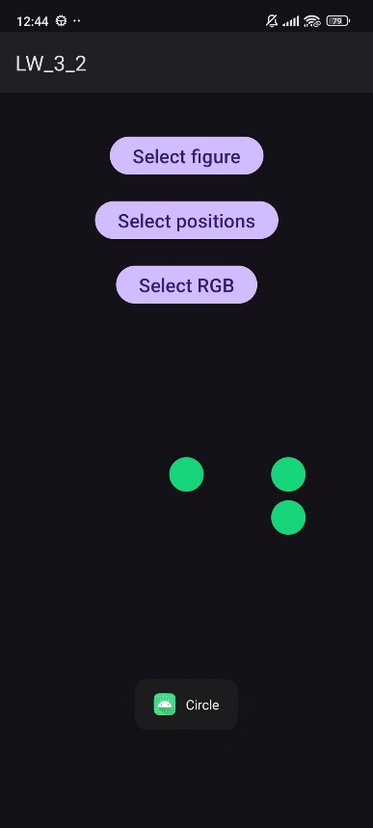
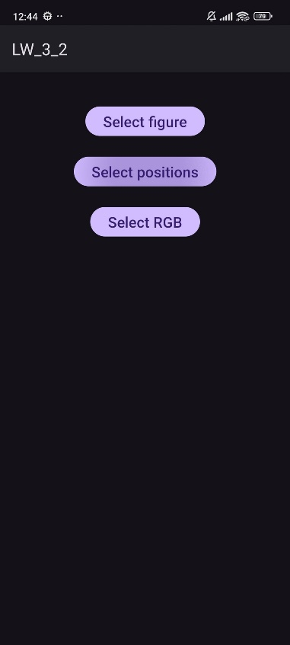
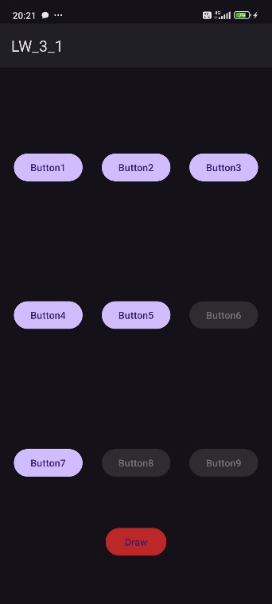
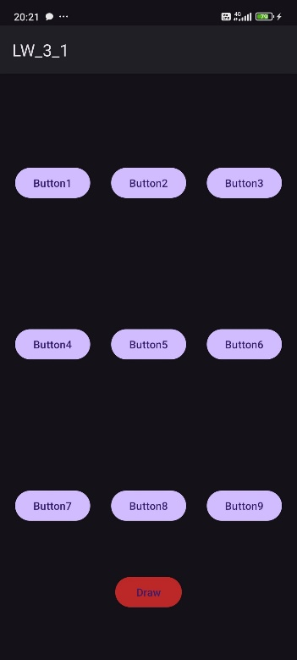
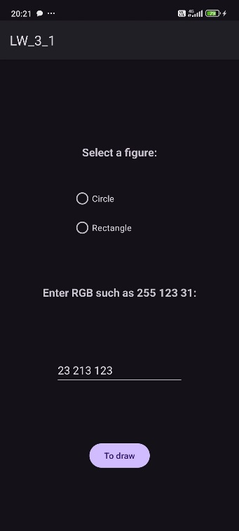
Вывод: в ходе лабораторной работы были получены практические навыки по создания и взаимодействия нескольких Activity.

